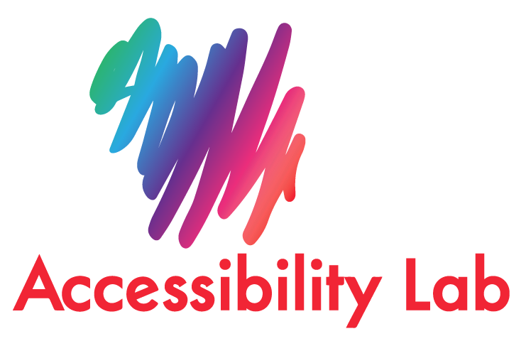

# Web Content Accessibility Guidelines (WCAG) 2.1 Audit

OnionShare Linux

<https://docs.onionshare.org/2.6/en/install.html#install-in-linux>

Tested in Linux Mint 21.1 x86_64

Start Date: 1 May 2023

End Date: 4 Jul 2023

Testing with blind user

[OnionShare Linux screen reader Orca testing - blind user](https://youtu.be/uswy3ky-cqY)

**Getting started testing with Orca**

[Orca](Orca%20Screen%20Reader) is a free, open source, flexible, and extensible screen reader that provides access to the graphical desktop via speech and refreshable braille.

Orca works with applications and toolkits that support the Assistive Technology Service Provider Interface (AT-SPI), which is the primary assistive technology infrastructure for Linux and Solaris. Applications and toolkits supporting the AT-SPI include the GNOME Gtk+ toolkit, the Java platform's Swing toolkit, LibreOffice, Gecko, and WebKitGtk. AT-SPI support for the KDE Qt toolkit is being pursued.

This document is a web accessibility audit of the platform according to the international standard Web Content Accessibility Guidelines 2.1 (WCAG 2.1), which is divided into four principles (Perceivable, Operable, Understandable and Robust), thirteen guidelines that contains requirements (success criteria) and three levels of conformance A, AA and AAA.

* A – the minimum level of compliance (critical for all)
* AA – the intermediate level (essential) (requirement for governments and telecom operators)
* AAA – the highest level of compliance (essential for some)

The purpose of this document is that designers and developers can recognize and implement the necessary changes to comply 100% with accessibility.

In this document we evaluate each requirement to indicate the following:

* "Not applicable": The requirement is not applicable; therefore, it is not evaluated.
* "Comply": the requirement is applicable, so it is evaluated and the result is satisfactory compliance.
* "Does not comply": the requirement is applicable, so it is evaluated and the result is non-compliance. In this case, we explain the reasons for non-compliance and the recommendation to follow.

Each accessibility barrier is classified in their corresponding requirement. Sometimes, we find one content that fails several requirements, on these cases, we classify the recommendation in the most representative requirement. And we only add a reference number in the other related requirements that the content is failing too. This way we do not repeat the same feedback in different requirements.

The assessment structure respects the structure of the WCAG 2.1 standard in order to facilitate the search for more information related to each requirement number.

Manual and automatic tests were carried out in the evaluation process, including testing with people with disabilities.

Once the audit is delivered, the development team can have a guide to know what modifications need to be made, understand the current accessibility status of the platform, define priorities based on compliance level A, AA, or AAA, and implement the recommended changes.

Finally, when recommendations are implemented, the content provider can have the following acknowledgments:

* **Accessibility Statement.**  A powerful declaration of commitment which is normally available in the footer via a link and includes information about the platform’s accessibility. <https://www.todoaccesible.com/declaracion_accesibiidad.html>
* **Add the W3C Conformance logo.**  The platform indicates a claim of conformance to a specified conformance level of the Web Content Accessibility Guidelines 2.1 [W3C](https://www.w3.org/WAI/standards-guidelines/wcag/conformance-logos/), could be level A, AA or AAA.

# Principle: Perceivable

## Guideline: Text Alternatives

## **Non-text Content:** All non-text content that is presented to the user has a text alternative that serves the equivalent purpose, except for the situations listed below.

* **Controls, Input:**If non-text content is a control or accepts user input, then it has a name that describes its purpose.
* **Time-Based Media:**If non-text content is time-based media, then text alternatives at least provide descriptive identification of the non-text content.
* **Test:**If non-text content is a test or exercise that would be invalid if presented in text, then text alternatives at least provide descriptive identification of the non-text content.
* **Sensory:**If non-text content is primarily intended to create a specific sensory experience, then text alternatives at least provide descriptive identification of the non-text content.
* **CAPTCHA:**If the purpose of non-text content is to confirm that content is being accessed by a person rather than a computer, then text alternatives that identify and describe the purpose of the non-text content are provided, and alternative forms of CAPTCHA using output modes for different types of sensory perception are provided to accommodate different disabilities.
* **Decoration, Formatting, Invisible:**If non-text content is pure decoration, is used only for visual formatting, or is not presented to users, then it is implemented in a way that it can be ignored by assistive technology.

|  |  |
| --- | --- |
| **Level** | **Compliance 1.1.1.** |
| **A** | **No** |

The intent of this Success Criterion is to make information conveyed by non-text content accessible through the use of a text alternative. Text alternatives are a primary way for making information accessible because they can be rendered through any sensory modality (for example, visual, auditory or tactile) to match the needs of the user. Providing text alternatives allows the information to be rendered in a variety of ways by a variety of user agents. For example, a person who cannot see a picture can have the text alternative read aloud using synthesized speech.

When the user enters to Share Files, there is a “List” element at the beginning, but we are not sure which element because the focus is not visible. Also, the description by its own, it is not sufficient to understand out of context, especially if there are not files to share yet.

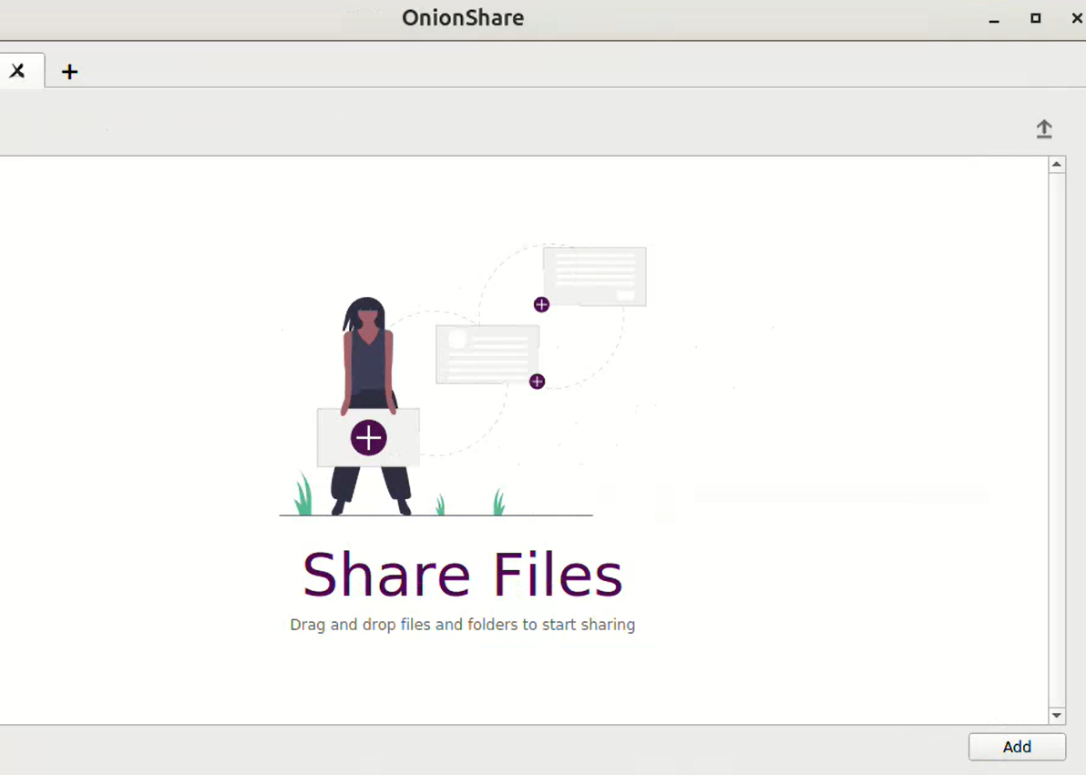

## Guideline: Time-based Media

## **Audio-only and Video-only (Prerecorded):** For prerecorded audio-only and prerecorded video-only media, the following are true, except when the audio or video is a media alternative for text and is clearly labeled as such:

* **Prerecorded Audio-only:**An alternative for time-based media is provided that presents equivalent information for prerecorded audio-only content.
* **Prerecorded Video-only:**Either an alternative for time-based media or an audio track is provided that presents equivalent information for prerecorded video-only content.

|  |  |
| --- | --- |
| **Level** | **Compliance 1.2.1.** |
| **A** | **Does not apply** |

## **Captions (Prerecorded):** Captions are provided for all prerecorded audio content in synchronized media, except when the media is a media alternative for text and is clearly labeled as such.

|  |  |
| --- | --- |
| **Level** | **Compliance 1.2.2.** |
| **A** | **Does not apply** |

## **Audio Description or Media Alternative (Prerecorded):** An alternative for time-based media or audio description of the prerecorded video content is provided for synchronized media, except when the media is a media alternative for text and is clearly labeled as such.

|  |  |
| --- | --- |
| **Level** | **Compliance 1.2.3.** |
| **A** | **Does not apply** |

## **Captions (Live):** Captions are provided for all live audio content in synchronized media.

|  |  |
| --- | --- |
| **Level** | **Compliance 1.2.4.** |
| **AA** | **Does not apply** |

## **Audio Description (Prerecorded):** Audio description is provided for all prerecorded video content in synchronized media.

|  |  |
| --- | --- |
| **Level** | **Compliance 1.2.5.** |
| **AA** | **Does not apply** |

## **Sign Language (Prerecorded):** Sign language interpretation is provided for all prerecorded audio content in synchronized media.

|  |  |
| --- | --- |
| **Level** | **Compliance 1.2.6.** |
| **AAA** | **Does not apply** |

## **Extended Audio Description (Prerecorded):** Where pauses in foreground audio are insufficient to allow audio descriptions to convey the sense of the video, extended audio description is provided for all prerecorded video content in synchronized media.

|  |  |
| --- | --- |
| **Level** | **Compliance 1.2.7.** |
| **AAA** | **Does not apply** |

## **Media Alternative (Prerecorded):** An alternative for time-based media is provided for all prerecorded synchronized media and for all prerecorded video-only media.

|  |  |
| --- | --- |
| **Level** | **Compliance 1.2.8.** |
| **AAA** | **Does not apply** |

## **Audio-only (Live):** An alternative for time-based media that presents equivalent information for live audio-only content is provided.

|  |  |
| --- | --- |
| **Level** | **Compliance 1.2.9.** |
| **AAA** | **Does not apply** |

## Guideline: Adaptable

## **Info and Relationships:** Information, structure, and relationships conveyed through presentation can be programmatically determined or are available in text.

|  |  |
| --- | --- |
| **Level** | **Compliance 1.3.1.** |
| **A** | **No** |

**Currently, there are inputs without a label related. Visually they are together but not in code because the screen reader is just announcing Text Unselected on the input or the number inside.**

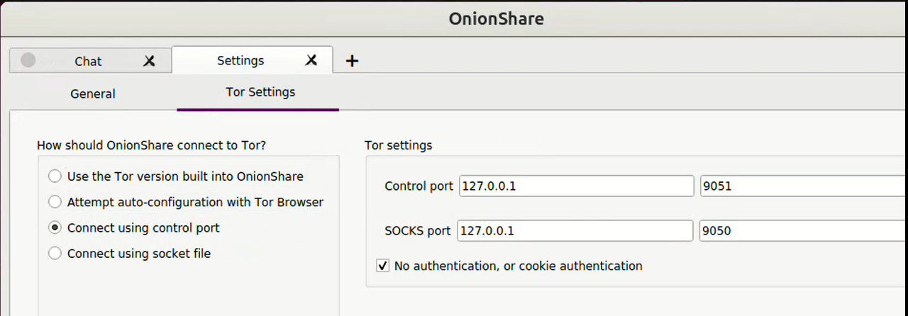

**Each input must have a visible label.**

Visible labels benefit all users. When form fields do not have labels that are meaningful and visible to all users, at all times, users might have to guess or infer what goes in them.

**Every form input needs a label, also known as an "accessible name." The label must be programmatically associated with the input, to remove all ambiguity.**

**Same logic applies to other inputs.**

## **Meaningful Sequence:** When the sequence in which content is presented affects its meaning, a correct reading sequence can be programmatically determined.

|  |  |
| --- | --- |
| **Level** | **Compliance 1.3.2.** |
| **A** | **Yes** |

## **Sensory Characteristics:** Instructions provided for understanding and operating content do not rely solely on sensory characteristics of components such as shape, size, visual location, orientation, or sound.

|  |  |
| --- | --- |
| **Level** | **Compliance 1.3.3.** |
| **A** | **No** |

The intent of this Success Criterion is to ensure that all users can access instructions for using the content, even when they cannot perceive shape or size or use information about spatial location or orientation.

**While using shape, provide visible label/name to the control.**

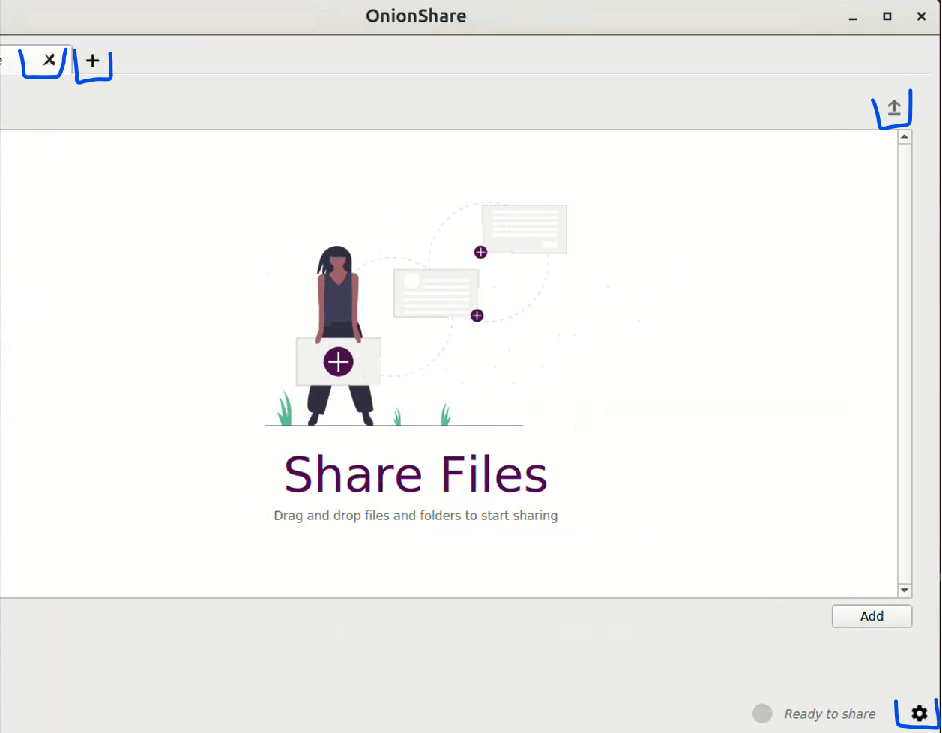

**Consider also the X button to remove the elements added in the list.**

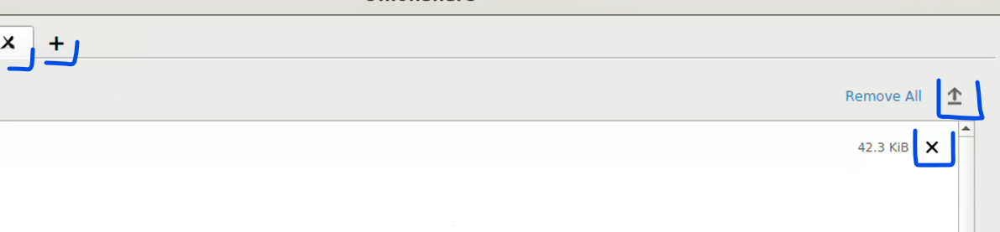

**For example:**

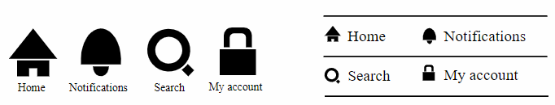

   

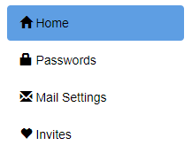



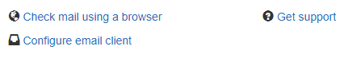







 

    

## **Orientation:** Content does not restrict its view and operation to a single display orientation, such as portrait or landscape, unless a specific display orientation is essential.

|  |  |
| --- | --- |
| **Level** | **Compliance 1.3.4.** |
| **AA** | **Does not apply** |

## **Identity Input Purpose:** The purpose of each input field collecting information about the user can be programmatically determined when:

* The input field serves a purpose identified in the Input Purposes for User Interface Components section; and
* The content is implemented using technologies with support for identifying the expected meaning for form input data.

|  |  |
| --- | --- |
| **Level** | **Compliance 1.3.5.** |
| **AA** | **Yes** |

## **Identify Purpose:** In content implemented using markup languages, the purpose of User Interface Components, icons, and regions can be programmatically determined.

|  |  |
| --- | --- |
| **Level** | **Compliance 1.3.6.** |
| **AAA** | **No** |

See 1.3.1.

## Guideline: Distinguishable

## **Use of Color:** Color is not used as the only visual means of conveying information, indicating an action, prompting a response, or distinguishing a visual element.

|  |  |
| --- | --- |
| **Level** | **Compliance 1.4.1.** |
| **A** | **Yes** |

## **Audio Control:** If any audio on a Web page plays automatically for more than 3 seconds, either a mechanism is available to pause or stop the audio, or a mechanism is available to control audio volume independently from the overall system volume level.

|  |  |
| --- | --- |
| **Level** | **Compliance 1.4.2.** |
| **A** | **Does not apply** |

## **Contrast (Minimum):** The visual presentation of text and images of text has a contrast ratio of at least 4.5:1, except for the following:

* **Large Text:**Large-scale text and images of large-scale text have a contrast ratio of at least 3:1;
* **Incidental:**Text or images of text that are part of an inactive user interface component, that are pure decoration, that are not visible to anyone, or that are part of a picture that contains significant other visual content, have no contrast requirement.
* **Logotypes:**Text that is part of a logo or brand name has no minimum contrast requirement.

|  |  |
| --- | --- |
| **Level** | **Compliance 1.4.3.** |
| **AA** | **No** |

**The intent of this Success Criterion is to provide enough contrast between text and its background so that it can be read by people with moderately low vision (who do not use contrast-enhancing assistive technology). For people without color deficiencies, hue and saturation have minimal or no effect on legibility as assessed by reading performance (Knoblauch et al., 1991). Color deficiencies can affect luminance contrast somewhat. Therefore, in the recommendation, the contrast is calculated in such a way that color is not a key factor so that people who have a color vision deficit will also have adequate contrast between the text and the background.**

**You can use one of these tools to validate any contrast.**

[Colour Contrast Analyser](http://www.paciellogroup.com/resources/contrastanalyser/)

[WebAIM Contrast Checker](http://webaim.org/resources/contrastchecker/)

**Observations in color contrasts apply the same than Windows.**

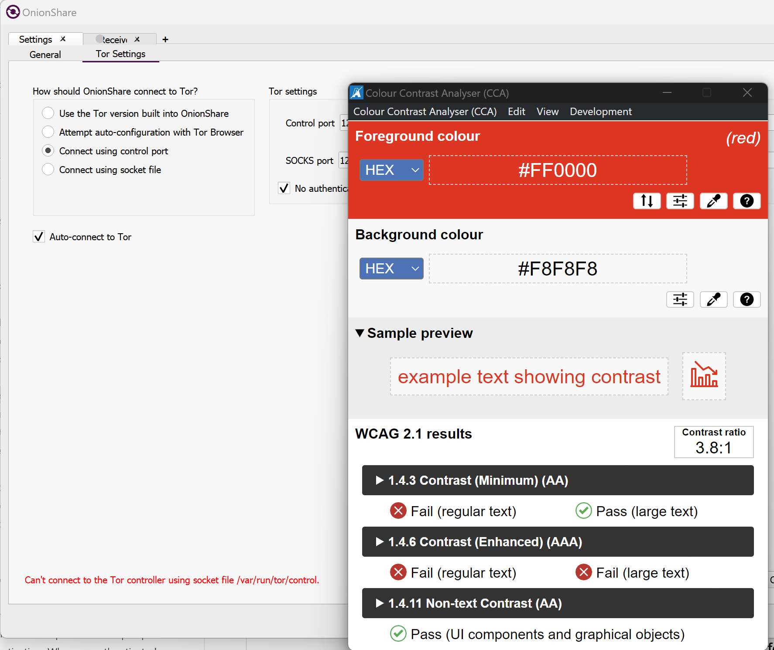

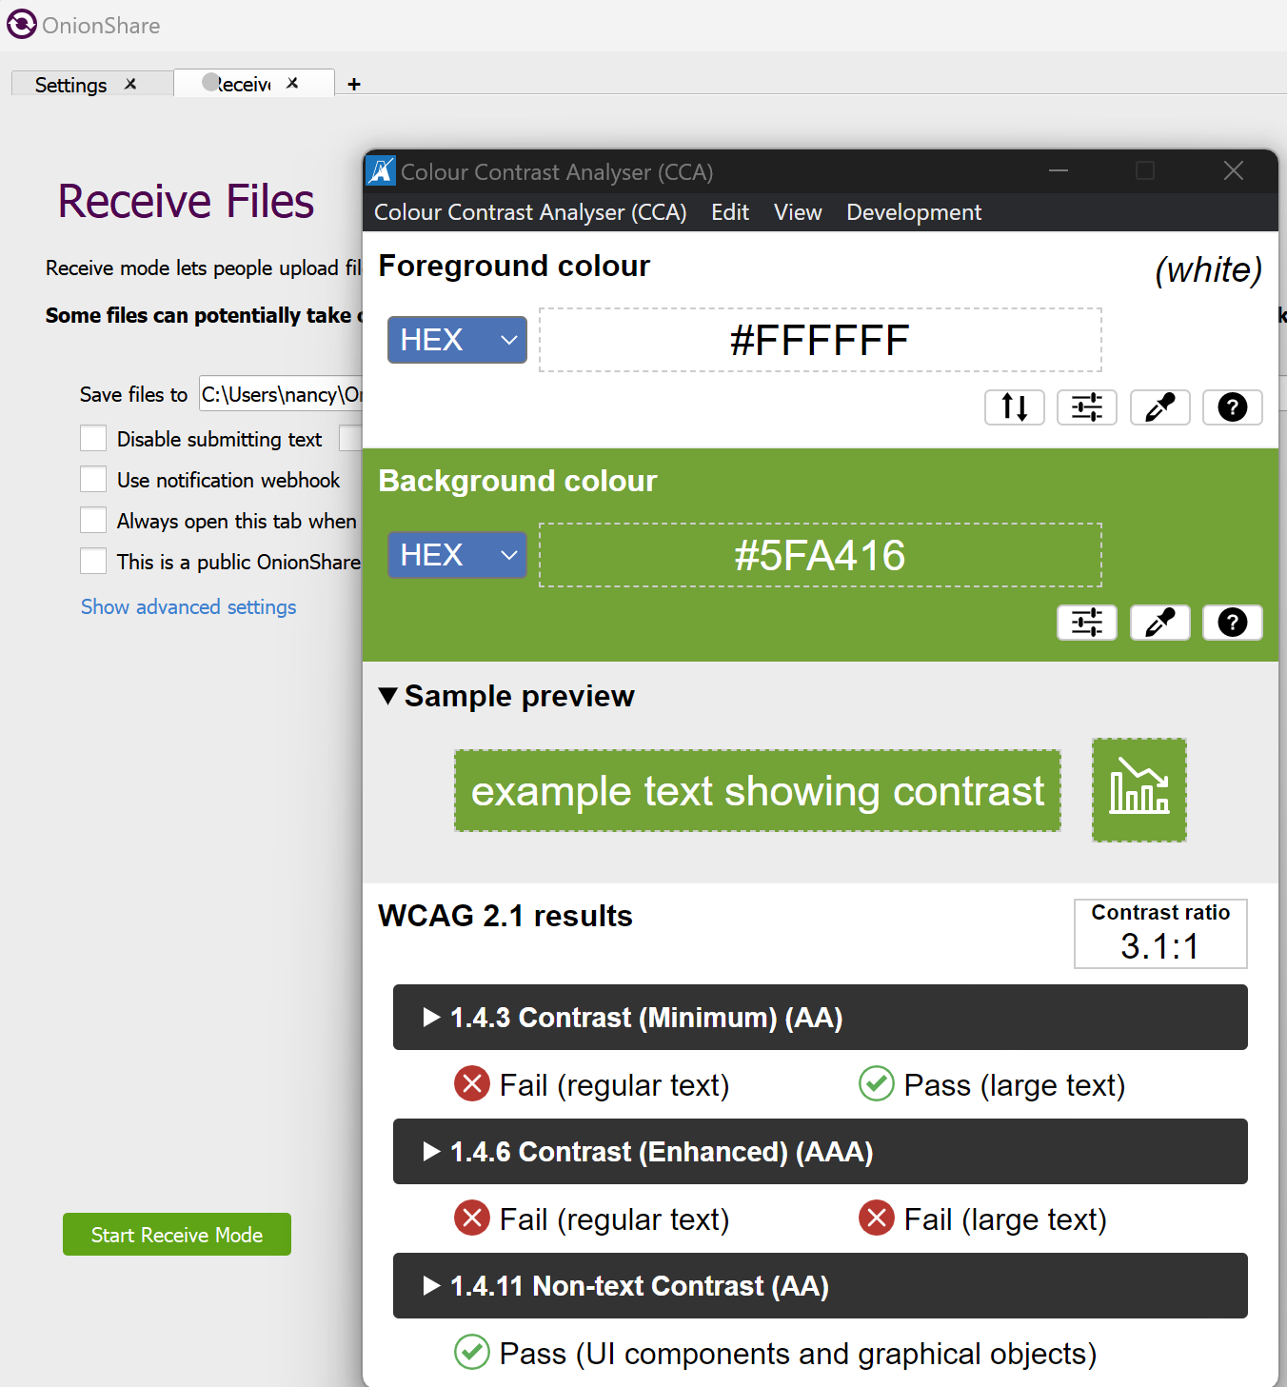

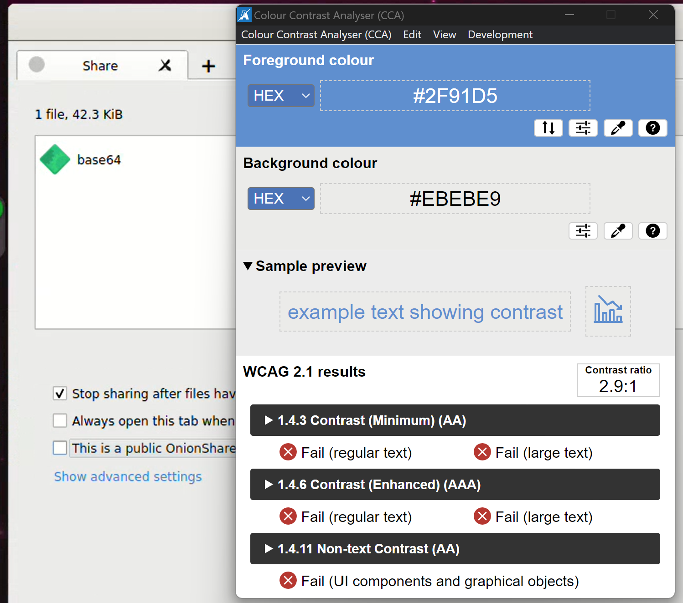

## **Resize text:** Except for captions and images of text, text can be resized without assistive technology up to 200 percent without loss of content or functionality.

|  |  |
| --- | --- |
| **Level** | **Compliance 1.4.4.** |
| **AA** | **Yes** |

## **Images of Text:** If the technologies being used can achieve the visual presentation, text is used to convey information rather than images of text except for the following:

* **Customizable:** The image of text can be visually customized to the user's requirements;
* **Essential:** A particular presentation of text is essential to the information being conveyed.

|  |  |
| --- | --- |
| **Level** | **Compliance 1.4.5.** |
| **AA** | **Does not apply** |

## **Contrast (Enhanced):** The visual presentation of text and images of text has a contrast ratio of at least 7:1, except for the following:

* **Large Text:**Large-scale text and images of large-scale text have a contrast ratio of at least 4.5:1;
* **Incidental:**Text or images of text that are part of an inactive user interface component, that are pure decoration, that are not visible to anyone, or that are part of a picture that contains significant other visual content, have no contrast requirement.
* **Logotypes:**Text that is part of a logo or brand name has no minimum contrast requirement.

|  |  |
| --- | --- |
| **Level** | **Compliance 1.4.6.** |
| **AAA** | **No** |

**See 1.4.3.**

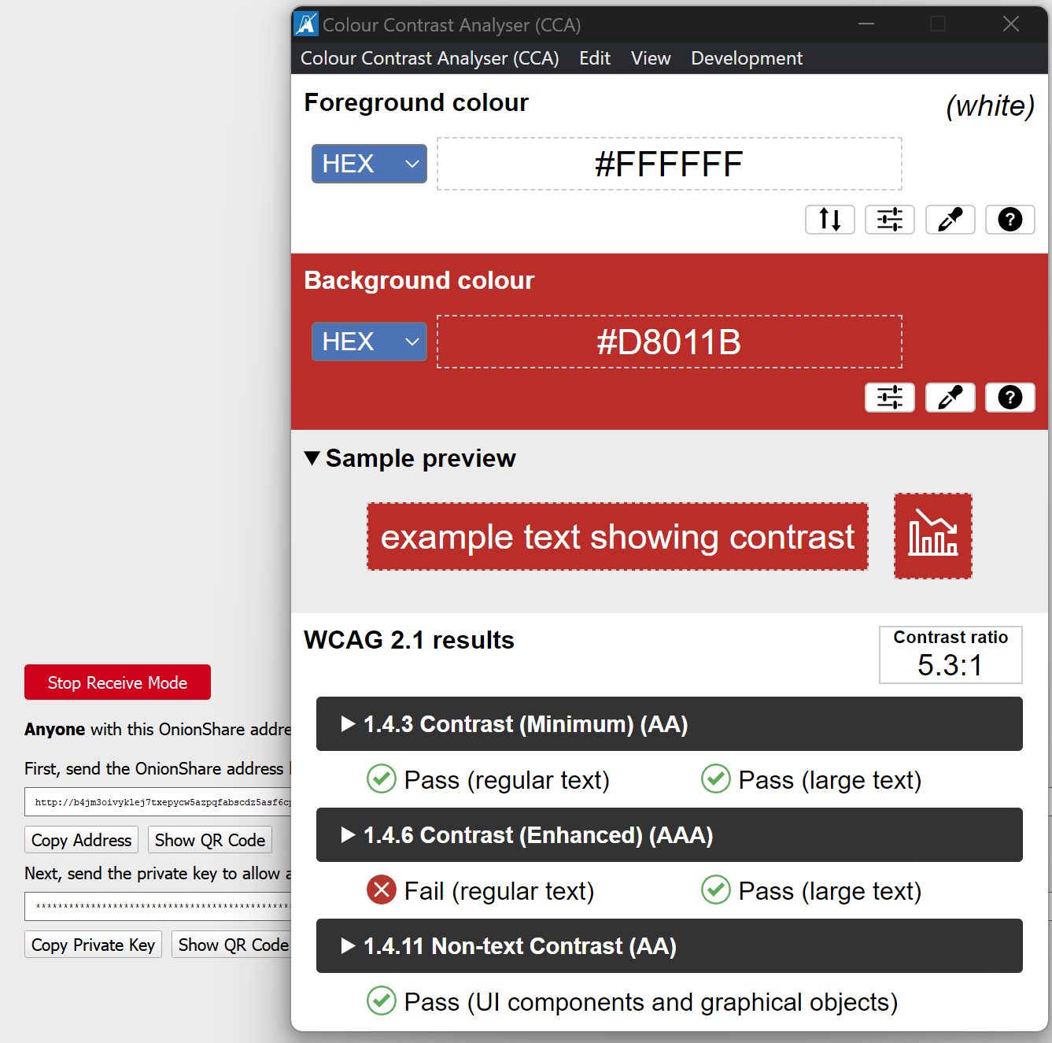

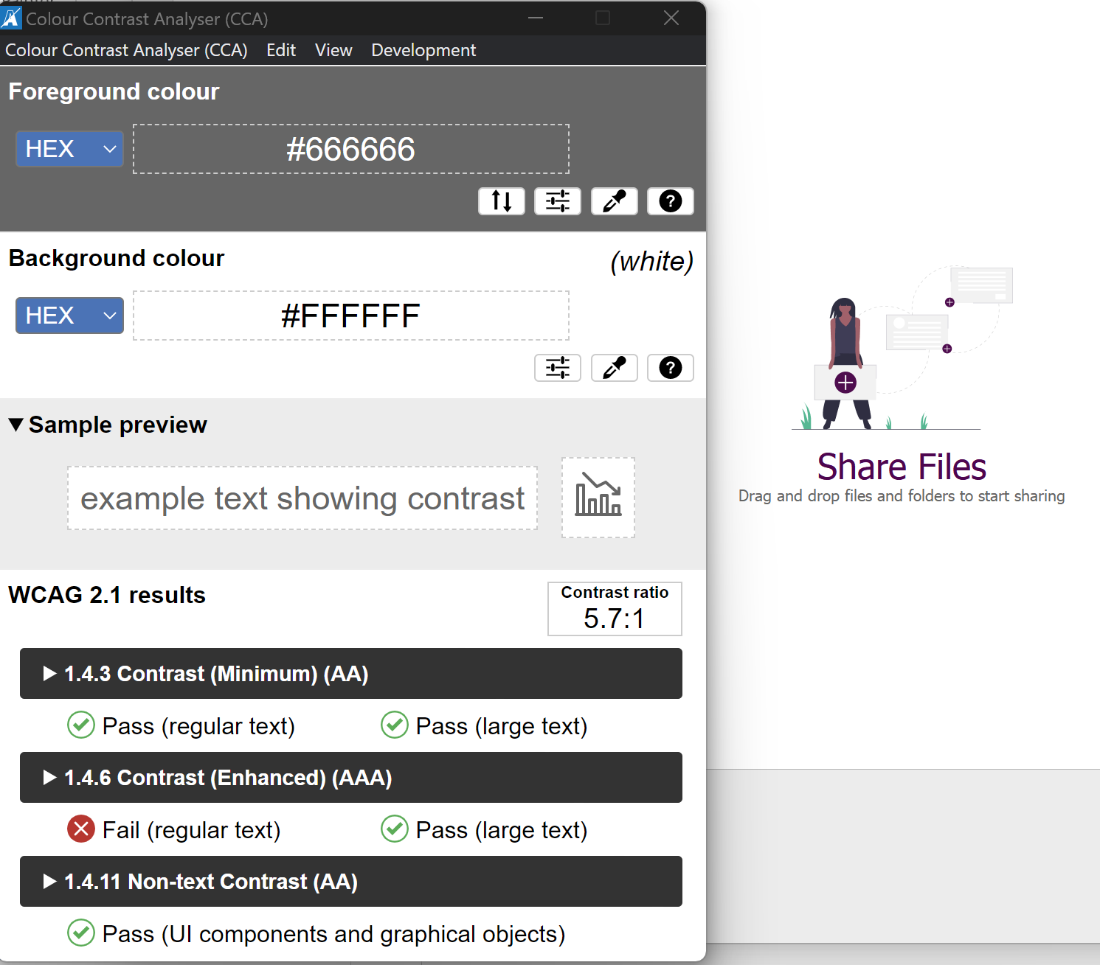

## **Low or No Background Audio:** For prerecorded audio-only content that (1) contains primarily speech in the foreground, (2) is not an audio CAPTCHA or audio logo, and (3) is not vocalization intended to be primarily musical expression such as singing or rapping, at least one of the following is true:

* **No Background:**The audio does not contain background sounds.
* **Turn Off:**The background sounds can be turned off.
* **20 dB:**The background sounds are at least 20 decibels lower than the foreground speech content, with the exception of occasional sounds that last for only one or two seconds.

|  |  |
| --- | --- |
| **Level** | **Compliance 1.4.7.** |
| **AAA** | **Does not apply** |

## **Visual Presentation:** For the visual presentation of blocks of text, a mechanism is available to achieve the following:

1. Foreground and background colors can be selected by the user.
2. Width is no more than 80 characters or glyphs (40 if CJK).
3. Text is not justified (aligned to both the left and the right margins).
4. Line spacing (leading) is at least space-and-a-half within paragraphs, and paragraph spacing is at least 1.5 times larger than the line spacing.
5. Text can be resized without assistive technology up to 200 percent in a way that does not require the user to scroll horizontally to read a line of text on a full-screen window.

|  |  |
| --- | --- |
| **Level** | **Compliance 1.4.8.** |
| **AAA** | **Does not apply** |

## **Images of Text (No Exception):** Images of text are only used for pure decoration or where a particular presentation of text is essential to the information being conveyed.

|  |  |
| --- | --- |
| **Level** | **Compliance 1.4.9.** |
| **AAA** | **Does not apply** |

## **Reflow:** Content can be presented without loss of information or functionality, and without requiring scrolling in two dimensions for:

* Vertical scrolling content at a width equivalent to 320 CSS pixels;
* Horizontal scrolling content at a height equivalent to 256 CSS pixels.

Except for parts of the content which require two-dimensional layout for usage or meaning.

|  |  |
| --- | --- |
| **Level** | **Compliance 1.4.10.** |
| **AA** | **Does not apply** |

## **Non-text Contrast:** The visual presentation of the following have a contrast ratio of at least 3:1 against adjacent color(s):

* **User Interface Components:** Visual information required to identify user interface components and states, except for inactive components or where the appearance of the component is determined by the user agent and not modified by the author;
* **Graphical Objects:** Parts of graphics required to understand the content, except when a particular presentation of graphics is essential to the information being conveyed.

|  |  |
| --- | --- |
| **Level** | **Compliance 1.4.11.** |
| **AA** | **No** |

The intent of this Success Criterion is to ensure that active user interface components (i.e., controls) and meaningful graphics are distinguishable by people with moderately low vision.

Low contrast controls are more difficult to perceive and may be completely missed by people with a visual impairment.

For active controls such as buttons, tabs, links, any visual information provided that is necessary for a user to identify that a control is present and how to operate it must have a minimum 3 to 1 contrast ratio with the adjacent colors.

Also, any visual information necessary to indicate state, such as whether a component is focus, hover, select, press, check, visited/unvisited, must also ensure that the information used to identify the control in that state has a minimum 3 to 1 contrast ratio.

**Active User Interface Component Examples**

For designing focus indicators, selection indicators and user interface components that need to be perceived clearly, the following are examples that have sufficient contrast:

Text input



Text input focus style



Text input using background color



Text input using background color focus style



More information and examples:

<https://www.w3.org/WAI/WCAG21/Understanding/non-text-contrast.html>

Currently, there is a focus, but this focus is not very clear. More color contrast and visible outline is recommended.

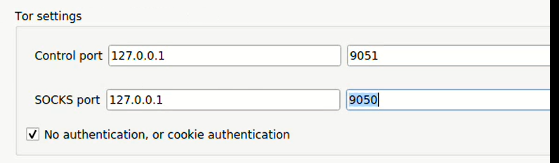

## **Text Spacing:** In content implemented using markup languages that support the following text style properties, no loss of content or functionality occurs by setting all of the following and by changing no other style property:

* Line height (line spacing) to at least 1.5 times the font size;
* Spacing following paragraphs to at least 2 times the font size;
* Letter spacing (tracking) to at least 0.12 times the font size;
* Word spacing to at least 0.16 times the font size.

Exception: Human languages and scripts that do not make use of one or more of these text style properties in written text can conform using only the properties that exist for that combination of language and script.

|  |  |
| --- | --- |
| **Level** | **Compliance 1.4.12.** |
| **AA** | **Does not apply** |

## **Content on Hover or Focus:** Where receiving and then removing pointer hover or keyboard focus triggers additional content to become visible and then hidden, the following are true:

* **Dismissable:** A mechanism is available to dismiss the additional content without moving pointer hover or keyboard focus, unless the additional content communicates an input error or does not obscure or replace other content;
* **Hoverable:** If pointer hover can trigger the additional content, then the pointer can be moved over the additional content without the additional content disappearing;
* **Persistent:** The additional content remains visible until the hover or focus trigger is removed, the user dismisses it, or its information is no longer valid.

Exception: The visual presentation of the additional content is controlled by the user agent and is not modified by the author.

|  |  |
| --- | --- |
| **Level** | **Compliance 1.4.13.** |
| **AA** | **Does not apply** |

# Principle: Operable

## Guideline: Keyboard Accessible

## **Keyboard:** All functionality of the content is operable through a keyboard interface without requiring specific timings for individual keystrokes, except where the underlying function requires input that depends on the path of the user's movement and not just the endpoints.

|  |  |
| --- | --- |
| **Level** | **Compliance 2.1.1.** |
| **A** | **Yes** |

## **No Keyboard Trap:** If keyboard focus can be moved to a component of the page using a keyboard interface, then focus can be moved away from that component using only a keyboard interface, and, if it requires more than unmodified arrow or tab keys or other standard exit methods, the user is advised of the method for moving focus away.

|  |  |
| --- | --- |
| **Level** | **Compliance 2.1.2.** |
| **A** | **Yes** |

## **Keyboard (No Exception):** All functionality of the content is operable through a keyboard interface without requiring specific timings for individual keystrokes.

|  |  |
| --- | --- |
| **Level** | **Compliance 2.1.3.** |
| **AAA** | **Yes** |

## **Character Key Shortcuts:** If a keyboard shortcut is implemented in content using only letter (including upper- and lower-case letters), punctuation, number, or symbol characters, then at least one of the following is true:

* **Turn off:** A mechanism is available to turn the shortcut off;
* **Remap:** A mechanism is available to remap the shortcut to use one or more non-printable keyboard characters (e.g. Ctrl, Alt, etc);
* **Active only on focus:** The keyboard shortcut for a user interface component is only active when that component has focus.

|  |  |
| --- | --- |
| **Level** | **Compliance 2.1.3.** |
| **AAA** | **Does not apply** |

## Guideline: Enough Time

## **Timing Adjustable:** For each time limit that is set by the content, at least one of the following is true:

* **Turn off:**The user is allowed to turn off the time limit before encountering it; or
* **Adjust:**The user is allowed to adjust the time limit before encountering it over a wide range that is at least ten times the length of the default setting; or
* **Extend:**The user is warned before time expires and given at least 20 seconds to extend the time limit with a simple action (for example, "press the space bar"), and the user is allowed to extend the time limit at least ten times; or
* **Real-time Exception:**The time limit is a required part of a real-time event (for example, an auction), and no alternative to the time limit is possible; or
* **Essential Exception:**The time limit is [essential](https://www.w3.org/TR/WCAG20/#essentialdef) and extending it would invalidate the activity; or
* **20 Hour Exception:**The time limit is longer than 20 hours.

|  |  |
| --- | --- |
| **Level** | **Compliance 2.2.1.** |
| **A** | **Does not apply** |

## **Pause, Stop, Hide:** For moving, blinking, scrolling, or auto-updating information, all of the following are true:

* **Moving, blinking, scrolling:**For any moving, blinking or scrolling information that (1) starts automatically, (2) lasts more than five seconds, and (3) is presented in parallel with other content, there is a mechanism for the user to pause, stop, or hide it unless the movement, blinking, or scrolling is part of an activity where it is essential; and
* **Auto-updating:**For any auto-updating information that (1) starts automatically and (2) is presented in parallel with other content, there is a mechanism for the user to pause, stop, or hide it or to control the frequency of the update unless the auto-updating is part of an activity where it is essential.

|  |  |
| --- | --- |
| **Level** | **Compliance 2.2.2.** |
| **A** | **Does not apply** |

## **No Timing:** Timing is not an essential part of the event or activity presented by the content, except for non-interactive synchronized media and real-time events.

|  |  |
| --- | --- |
| **Level** | **Compliance 2.2.3.** |
| **AAA** | **Does not apply** |

## **Interruptions:** Interruptions can be postponed or suppressed by the user, except interruptions involving an emergency.

|  |  |
| --- | --- |
| **Level** | **Compliance 2.2.4.** |
| **AAA** | **Does not apply** |

## **Re-authenticating:** When an authenticated session expires, the user can continue the activity without loss of data after re-authenticating.

|  |  |
| --- | --- |
| **Level** | **Compliance 2.2.5.** |
| **AAA** | **Does not apply** |

## **Timeouts:** Users are warned of the duration of any user inactivity that could cause data loss, unless the data is preserved for more than 20 hours when the user does not take any actions.

|  |  |
| --- | --- |
| **Level** | **Compliance 2.2.6.** |
| **AAA** | **Does not apply** |

## Guideline: Seizures and Physical Reactions

## **Three Flashes or Below Threshold:** Web pages do not contain anything that flashes more than three times in any one second period, or the flash is below the general flash and red flash thresholds.

|  |  |
| --- | --- |
| **Level** | **Compliance 2.3.1.** |
| **A** | **Does not apply** |

## **Three Flashes:** Web pages do not contain anything that flashes more than three times in any one second period.

|  |  |
| --- | --- |
| **Level** | **Compliance 2.3.2.** |
| **AAA** | **Does not apply** |

## **Animation from Interactions:** Motion animation triggered by interaction can be disabled, unless the animation is essential to the functionality or the information being conveyed.

|  |  |
| --- | --- |
| **Level** | **Compliance 2.3.3.** |
| **AAA** | **Does not apply** |

## Guideline: Navigable

## **Bypass Blocks:** A mechanism is available to bypass blocks of content that are repeated on multiple Web pages.

|  |  |
| --- | --- |
| **Level** | **Compliance 2.4.1.** |
| **A** | **Does not apply** |

## **Page Titled:** Web pages have titles that describe topic or purpose.

|  |  |
| --- | --- |
| **Level** | **Compliance 2.4.2.** |
| **A** | **Yes** |

## **Focus Order:** If a Web page can be navigated sequentially and the navigation sequences affect meaning or operation, focusable components receive focus in an order that preserves meaning and operability.

|  |  |
| --- | --- |
| **Level** | **Compliance 2.4.3.** |
| **A** | **No** |

**The intent of this Success Criterion is to ensure that when users navigate sequentially through content, they encounter information in an order that is consistent with the meaning of the content and can be operated from the keyboard. This reduces confusion by letting users form a consistent mental model of the content. There may be different orders that reflect logical relationships in the content.**

**Like in Windows, the focus order is that the checkbox of Auto-connect to Tor, is receiving focus every time after selecting one option (How should OnionShare connect to Tor) and before offering the options of that selection. After choosing an option, the next Tab focus should go directly to the first element of that option.**

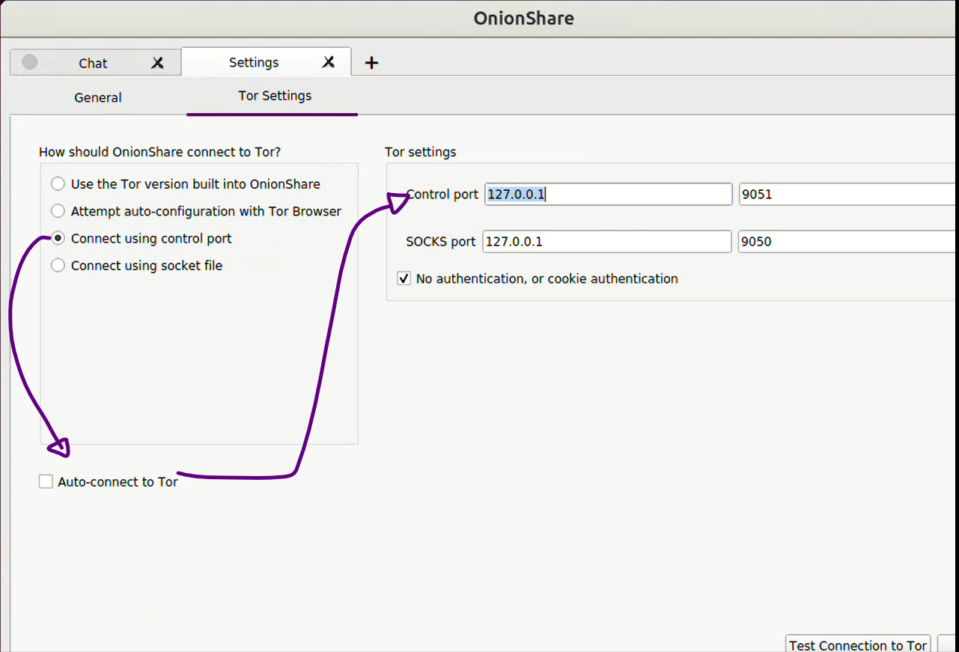

**Receive Files, also has a weird focus order with Tab. The focus does not move in order of the elements on the screen. First tab is on the Receive Tab, then is lost two Tabs, and finally shows up in the “Always open this tab when OnionShare is started” checkbox. Then the focus advances a couple of elements and move up again.**

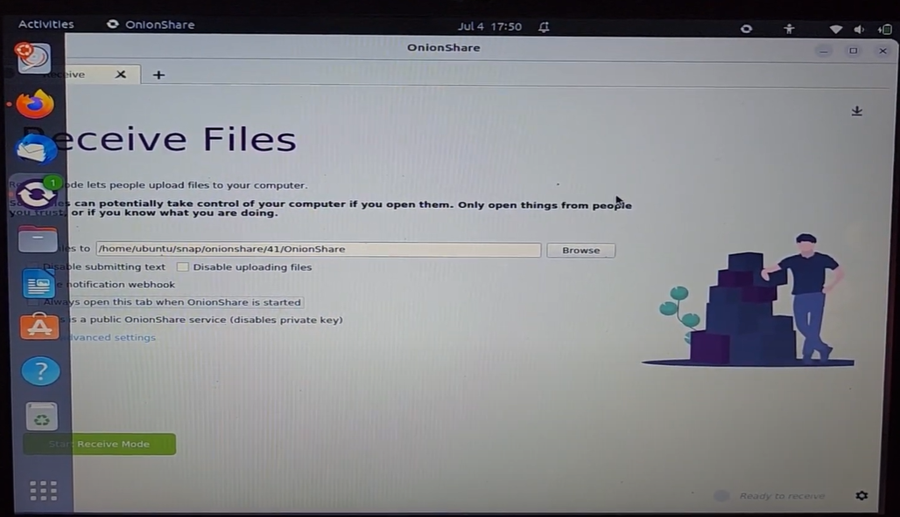

## **Link Purpose (In Context):** The purpose of each link can be determined from the link text alone or from the link text together with its programmatically determined link context, except where the purpose of the link would be ambiguous to users in general.

|  |  |
| --- | --- |
| **Level** | **Compliance 2.4.4.** |
| **A** | **Yes** |

## **Multiple Ways:** More than one way is available to locate a Web page within a set of Web pages except where the Web Page is the result of, or a step in, a process.

|  |  |
| --- | --- |
| **Level** | **Compliance 2.4.5.** |
| **AA** | **Does not apply** |

## **Headings and Labels:** Headings and labels describe topic or purpose.

|  |  |
| --- | --- |
| **Level** | **Compliance 2.4.6.** |
| **AA** | **Yes** |

## **Focus Visible:** Any keyboard operable user interface has a mode of operation where the keyboard focus indicator is visible.

|  |  |
| --- | --- |
| **Level** | **Compliance 2.4.7.** |
| **AA** | **No** |

**All focusable elements must have a visual focus and visual hover indicator when in focus.**

As users tab through links elements, they must be able to see where the keyboard focus is. A visual focus indicator should also be available to mouse users. You can also enhance the active states.

**Currently, on the four big options, there is a minimal change of style when in focus (a little change in the color of the square line) and hover (a little change on the color shadow), but these little changes are almost not visible. So, we recommend to change the style so it can be obvious where the mouse or focus is. (Same as Windows)**

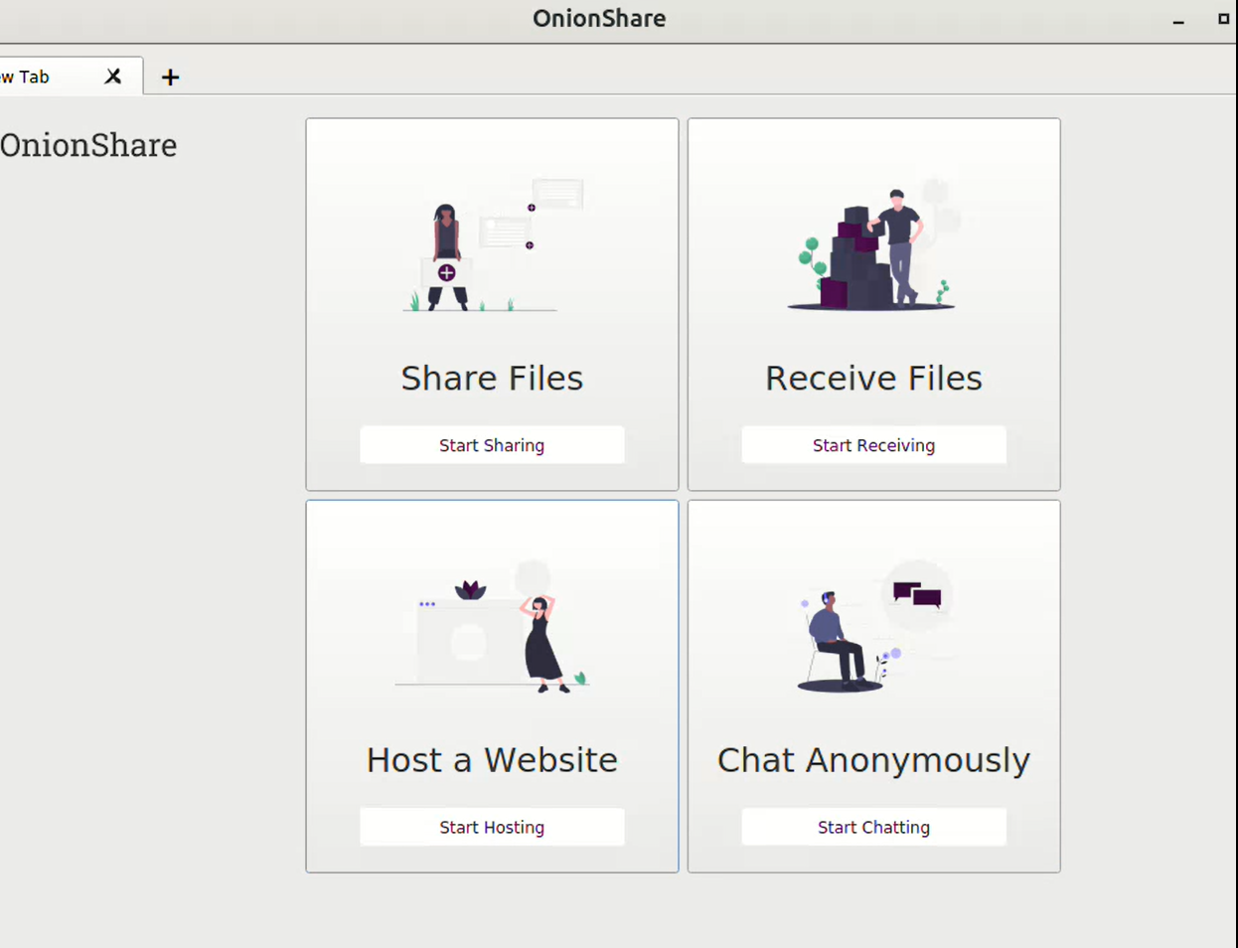

Note: you could create different styles for each of the different states — focus, hover, and active — but you don't have to. Sometimes it makes more sense to give them all the same style.

A similar issue is on the green button “Start sharing” and red button of “Stop sharing”, it does have a focus, but this focus is almost invisible, so we recommend to design a more visible focus.

**With focus:**

  

**Without focus:**

  

## **Location:** Information about the user's location within a set of Web pages is available.

|  |  |
| --- | --- |
| **Level** | **Compliance 2.4.8.** |
| **AAA** | **Does not apply** |

## **Link Purpose (Link Only):** A mechanism is available to allow the purpose of each link to be identified from link text alone, except where the purpose of the link would be ambiguous to users in general.

|  |  |
| --- | --- |
| **Level** | **Compliance 2.4.9.** |
| **AAA** | **Yes** |

## **Section Headings:** Section headings are used to organize the content.

|  |  |
| --- | --- |
| **Yesterday** | **Compliance 2.4.10.** |
| **AAA** | **Does not apply** |

## Guideline: Input Modalities

## **Pointer Gestures:** All functionality that uses multipoint or path-based gestures for operation can be operated with a single pointer without a path-based gesture, unless a multipoint or path-based gesture is essential.

|  |  |
| --- | --- |
| **Level** | **Compliance 2.5.1.** |
| **A** | **Does not apply** |

## **Pointer Cancellations:** For functionality that can be operated using a single pointer, at least one of the following is true:

* **No Down-Event:** The down-event of the pointer is not used to execute any part of the function;
* **Abort or Undo:** Completion of the function is on the up-event, and a mechanism is available to abort the function before completion or to undo the function after completion;
* **Up Reversal:** The up-event reverses any outcome of the preceding down-event;
* **Essential:** Completing the function on the down-event is essential.

|  |  |
| --- | --- |
| **Level** | **Compliance 2.5.2.** |
| **A** | **Yes** |

## **Label in Name:** For user interface components with labels that include text or images of text, the name contains the text that is presented visually.

|  |  |
| --- | --- |
| **Level** | **Compliance 2.5.3.** |
| **A** | **No** |

See 1.3.1.

## **Motion Actuation:** Functionality that can be operated by device motion or user motion can also be operated by user interface components and responding to the motion can be disabled to prevent accidental actuation, except when:

* **Supported Interface:** The motion is used to operate functionality through an accessibility supported interface;
* **Essential:** The motion is essential for the function and doing so would invalidate the activity.

|  |  |
| --- | --- |
| **Level** | **Compliance 2.5.4.** |
| **A** | **Does not apply** |

## **Target Size:** The size of the target for pointer inputs is at least 44 by 44 CSS pixels except when:

* **Equivalent:** The target is available through an equivalent link or control on the same page that is at least 44 by 44 CSS pixels;
* **Inline:** The target is in a sentence or block of text;
* **User Agent Control:** The size of the target is determined by the user agent and is not modified by the author;
* **Essential:** A particular presentation of the target is essential to the information being conveyed.

|  |  |
| --- | --- |
| **Level** | **Compliance 2.5.5.** |
| **AAA** | **Does not apply** |

## **Concurrent Input Mechanisms:** Web content does not restrict use of input modalities available on a platform except where the restriction is essential, required to ensure the security of the content, or required to respect user settings.

|  |  |
| --- | --- |
| **Level** | **Compliance 2.5.6.** |
| **AAA** | **Yes** |

# Principle: Understandable

## Guideline: Readable

## **Language of Page:** The default human language of each Web page can be programmatically determined.

|  |  |
| --- | --- |
| **Level** | **Compliance 3.1.1.** |
| **A** | **Yes** |

## **Language of Parts:** The human language of each passage or phrase in the content can be programmatically determined except for proper names, technical terms, words of indeterminate language, and words or phrases that have become part of the vernacular of the immediately surrounding text.

|  |  |
| --- | --- |
| **Level** | **Compliance 3.1.2.** |
| **AA** | **Does not apply** |

## **Unusual Words:** A mechanism is available for identifying specific definitions of words or phrases used in an unusual or restricted way, including idioms and jargon.

|  |  |
| --- | --- |
| **Level** | **Compliance 3.1.3.** |
| **AAA** | **Does not apply** |

## **Abbreviations:** A mechanism for identifying the expanded form or meaning of abbreviations is available.

|  |  |
| --- | --- |
| **Level** | **Compliance 3.1.4.** |
| **AAA** | **Does not apply** |

## **Reading Level:** When text requires reading ability more advanced than the lower secondary education level after removal of proper names and titles, supplemental content, or a version that does not require reading ability more advanced than the lower secondary education level, is available.

|  |  |
| --- | --- |
| **Level** | **Compliance 3.1.5.** |
| **AAA** | **Does not apply** |

## **Pronunciation:** A mechanism is available for identifying specific pronunciation of words where meaning of the words, in context, is ambiguous without knowing the pronunciation.

|  |  |
| --- | --- |
| **Level** | **Compliance 3.1.6.** |
| **AAA** | **Does not apply** |

## Guideline: Predictable

## **On Focus:** When any component receives focus, it does not initiate a change of context.

|  |  |
| --- | --- |
| **Level** | **Compliance 3.2.1.** |
| **A** | **Yes** |

## **On Input:** Changing the setting of any user interface component does not automatically cause a change of context unless the user has been advised of the behavior before using the component.

|  |  |
| --- | --- |
| **Level** | **Compliance 3.2.2.** |
| **A** | **Yes** |

## **Consistent Navigation:** Navigational mechanisms that are repeated on multiple Web pages within a set of Web pages occur in the same relative order each time they are repeated, unless a change is initiated by the user.

|  |  |
| --- | --- |
| **Level** | **Compliance 3.2.3.** |
| **AA** | **Yes** |

## **Consistent Identification:** Components that have the same functionality within a set of Web pages are identified consistently.

|  |  |
| --- | --- |
| **Level** | **Compliance 3.2.4.** |
| **AA** | **Yes** |

## **Change on Request:** Changes of context are initiated only by user request or a mechanism is available to turn off such changes.

|  |  |
| --- | --- |
| **Level** | **Compliance 3.2.5.** |
| **AAA** | **Yes** |

## Guideline: Input Assistance

## **Error Identification:** If an input error is automatically detected, the item that is in error is identified and the error is described to the user in text.

|  |  |
| --- | --- |
| **Level** | **Compliance 3.3.1.** |
| **A** | **Yes** |

## **Labels or Instructions:** Labels or instructions are provided when content requires user input.

|  |  |
| --- | --- |
| **Level** | **Compliance 3.3.2.** |
| **A** | **Yes** |

## **Error Suggestion:** If an input error is automatically detected and suggestions for correction are known, then the suggestions are provided to the user, unless it would jeopardize the security or purpose of the content.

|  |  |
| --- | --- |
| **Level** | **Compliance 3.3.3.** |
| **AA** | **Does not apply** |

## **Error Prevention (Legal, Financial, Data):** For Web pages that cause legal commitments or financial transactions for the user to occur, that modify or delete user-controllable data in data storage systems, or that submit user test responses, at least one of the following is true:

1. **Reversible:**Submissions are reversible.
2. **Checked:**Data entered by the user is checked for input errors and the user is provided an opportunity to correct them.
3. **Confirmed:**A mechanism is available for reviewing, confirming, and correcting information before finalizing the submission.

|  |  |
| --- | --- |
| **Level** | **Compliance 3.3.4.** |
| **AA** | **Does not apply** |

## **Help:** Context-sensitive help is available.

|  |  |
| --- | --- |
| **Level** | **Compliance 3.3.5.** |
| **AAA** | **Yes** |

## **Error Prevention (All):** For Web pages that require the user to submit information, at least one of the following is true:

1. **Reversible:**Submissions are reversible.
2. **Checked:**Data entered by the user is checked for input errors and the user is provided an opportunity to correct them.
3. **Confirmed:**A mechanism is available for reviewing, confirming, and correcting information before finalizing the submission.

|  |  |
| --- | --- |
| **Level** | **Compliance 3.3.6.** |
| **AAA** | **Does not apply** |

# Principle: Robust

## Guideline: Compatible

## **Parsing:** In content implemented using markup languages, elements have complete start and end tags, elements are nested according to their specifications, elements do not contain duplicate attributes, and any IDs are unique, except where the specifications allow these features.

|  |  |
| --- | --- |
| **Level** | **Compliance 4.1.1.** |
| **A** | **Does not apply** |

## **Name, Role, Value:** For all user interface components (including but not limited to: form elements, links and components generated by scripts), the name and role can be programmatically determined; states, properties, and values that can be set by the user can be programmatically set; and notification of changes to these items is available to user agents, including assistive technologies.

|  |  |
| --- | --- |
| **Level** | **Compliance 4.1.2.** |
| **A** | **Yes** |

## **Status Messages:** In content implemented using markup languages, status messages can be programmatically determined through role or properties such that they can be presented to the user by assistive technologies without receiving focus.

|  |  |
| --- | --- |
| **Level** | **Compliance 4.1.3.** |
| **AA** | **No** |

Sighted users can observe and interact with visible content changes or updates on the screen (e.g. error messages, progress bars, shopping carts). People who are blind or have low vision using assistive technology might not be aware of these changes. To be accessible, status messages alert assistive technology users to these changes without moving focus away from their current location on the screen. This allows them to hear the changes or updates being made without interrupting their work or disorienting them on the page.

Currently, the status messages in red texts are not accessible for screen reader:





Same logic for the progress bars.

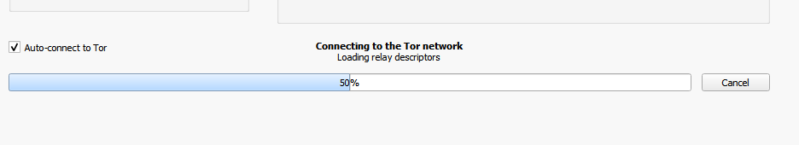

# Additional note

As alternative we tested in Ubuntu 23.04 with screen reader but there were no descriptions for the elements. Issue that is probably more related to the lack of accessibility in Ubuntu:

[OnionShare Ubuntu screen reader Orca testing (not accessible)](https://youtu.be/D_0_K7Pk1ZI)

# Source

Web Content Accessibility Guidelines 2.1

<https://www.w3.org/TR/WCAG21/>